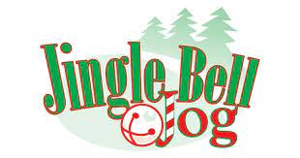
Flair Kit Order Form

Please submit this form and include payment in a sealed envelope and turn in to the Jingle Jog collection basket at the front office between 11/29-12/10!
1. Student Name and Teacher/Grade:
2. Student Name and Teacher/Grade:
3. Student Name and Teacher/Grade:
4. Student Name and Teacher/Grade:
5. Student Name and Teacher/Grade:
Please mark which kit you would like to order:
____ $2 Kit Includes: ribbons and 4 bells to attach to shoelaces.
____ $5 Kit Includes: ribbons and 4 bells to attach to shoelaces and 4 bells for a jingle bracelet.
Total Number of Kits Ordered:
Total Payment Amount Enclosed_________
(Payment is due with order form/Checks can be made out to SVE PTA)

*** Flair Kits will be delivered to students’ classroom the morning of the jog. ***
**Proceeds from the sale will be donated to WISH WEEK

